Toolbox for Analysis of Flexural Isostasy (TAFI)

version 1.0

Sumant Jha, Dennis L. Harry and Derek L. Schutt

Colorado State University

**Table of contents**

Introduction 3

Installation 3

Running toolbox 3

Using TAFI 4

Plate Geometry 4

Load Geometry 5

**Load Magnitude** 5

**Load Position** 6

**Load Wavelength** 6

Flexural Rigidity 6

Elastic Thickness 7

Density Structure 7

Plot Parameter 7

Data Import 7

Data Shift 8

Outputs 8

Push Buttons 9

Plot Flexure 9

Plot Gravity 9

Clear All Curves 9

Reset All Plots 9

Clear All Data 10

Contextual Menu 10

File 10

Change Defaults 10

Utilities 11

About 11

Tools 11

Functions Callable outside TAFI 12

Decision table for plate and load geometry combinations 12

**Introduction**

TAFI allows a user to compute the flexural response to loading for various plate types. The parameters can be adjusted using sliders or input boxes. The responses are displayed in form of 2-D plots. The gravity responses for such flexural basin shapes are also displayed. This program allows a user to import their own data to compare it with the flexure and gravity profile. The data so imported can be shifted up and down to aid modeling.

**Installation**

Download and unzip TAFI.zip file at a preferred location.

From Matlab's workspace, cd to the unzipped TAFI directory.

Alternatively

Add path of the TAFI directory and subdirectories in Matlab.

On Unix and Mac, this can be done as:

setenv MATLABPATH<path of unzipped TAFI main directory>

On windows or any other operating system, its best to use a Use a

startup.m File.

See here for adding path in Matlab:

http://www.mathworks.com/help/matlab/matlab_env/add-folders-to-

search-path-upon-startup-on-unix-or-macintosh.html

Alternatively

Use Matlab's install app tool and install TAFI app using “TAFI.mlappinstall" file in Matlab's App ribbon bar.

Bugs: Send all bugs, with error messages to sumant.jha@colostate.edu.

**Running toolbox**

If path to TAFI main directory is not set:

* * cd to TAFI main directory in Matlab
* * Enter "TAFI" in Matlab workspace in TAFI main directory.

If path to TAFI main directory set:

* * Enter "TAFI" in Matlab workspace

If app installed in Matlab's app ribbon bar:

* * Click on the TAFI app icon.

+++ Depending on computer configuration, TAFI may need a few seconds to start.+++

**Using TAFI**

The following sections describe how to use TAFI to understand and model flexural deflection.

**Plate Geometry**

The plate geometry in TAFI can be:

1. Infinite plate

In this configuration of plate, the plate is continuous and extends infinitely in both directions.

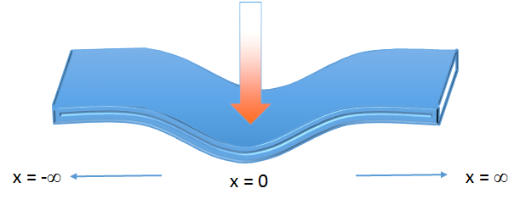

2. Semi-Infinite plate

In this configuration of plate, the plate is broken at x = 0 and extends infinitely in both directions.

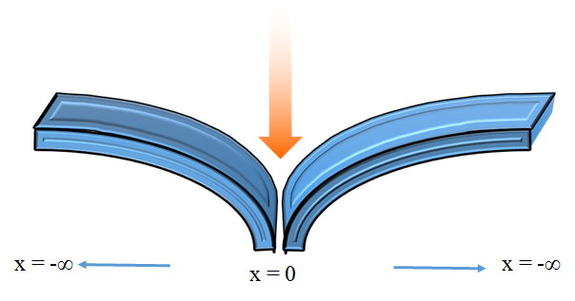

One of these two plate geometry can be selected from the "Plate Geometry" dropdown menu.

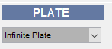

**Load Geometry**

The load geometry in TAFI can be:

1. 2-D Impulse load

2. 3-D Impulse load

3. Sinusoidal load

4. 2-D Distributed load

5. Distributed axisymmetric load



**Load Magnitude**

The magnitude of impulse and sinusoidal loads are specified using the "Load Magnitude" slider and edit box.



The distributed load magnitudes are specified through a load file, which is imported into TAFI through Import Load window. This window opens up, when the user selects one of the two distributed load option in the "Load Geometry" dropdown menu.

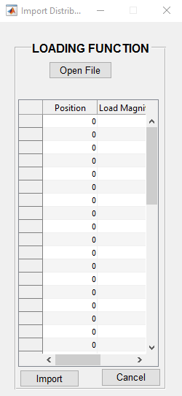

The distributed load file is formatted as below:

The input files containing the load functions can be in either text or Excel format. The 2-D distributed load function should be formatted in two columns, the first providing the position (in km) of the data point relative to an origin chosen by the user, and the second column providing load magnitudes (in N/m or N/m2).

The 3-D distribute load function is formatted in one column in the following manner:

Row1: ∆x - Spacing along X direction

Row2: ∆y - Spacing along Y direction

Row3: nx - Number of nodes in X direction

Row4: ny - Number of nodes in Y direction

Row5: Load - Vector of load magnitude corresponding to each node. The nodes are arranged as:

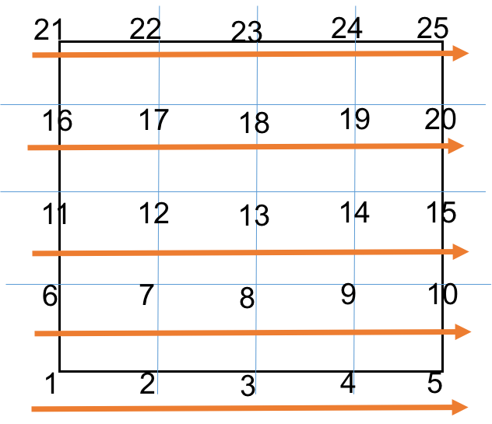

In case of distributed load, the load magnitude slider changes to "Load Scale" slider with value ranging from 0-10. This scaling can be used to scale the magnitude of imported load.



**Load Position**

The load position slider specifies the position of the load on the plate.



**Load Wavelength**

The “Load Wavelength” slider is active only when the ”Periodic loading” option is selected from the "Load Geometry" dropdown menu, and ranges from 1 to 40,000 km (the circumf

erence of the Earth), with a default value of 1 km.



**Flexural Rigidity**

Flexural rigidity (D) is the resistance offered by a plate while undergoing bending due to any load applied to it. It can be related to the elastic thickness (Te) of a plate by the formula

D = E*Te3/12(1-v2),

where, E is the Elastic Modulus and v is Poisson’s ratio. Elastic Modulus for this GUI is by default taken as 8 x 1010 N/m2, and the Poisson’s ratio is taken at 0.25.

In TAFI, the flexural rigidity can be specified with the "Flexural Rigidity" slider.



**Elastic Thickness**

The elastic thickness (Te) of a plate is directly proportional to the Flexural Rigidity value and is calculated by

rearranging the terms of Flexural Rigidity equation. In TAFI, Te can not be specified directly. However, Te is related to D. So, by changing D and observing the Te value in its edit box, elastic thickness can be used as input.

**Density Structure**

The elastic plate is assumed to include density interfaces at the top of the plate and at the crust-mantle boundary prior to flexure. These are defined by specifying the density of the basin fill, crust, and mantle, and the depth to the interfaces prior to flexure.

These densities and depths are specified with the “Infill Density”, “Crust Density”, “Mantle Density”, “1st Interface Depth” and “2nd Interface Depth” edit boxes.

The mantle and infill densities are required to calculate the flexural parameter,, which is used to calculate the flexural deflection of the lithosphere for non-harmonic loads (Equations 4-6). The density contrasts between these layers is also used when calculating the gravity anomaly (Equation 8) associated with flexure of the lithosphere

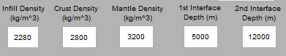

**Plot Parameter**

The flexural profile is computed and plotted between positions “Xmin” and “Xmax”, which are defined with the respectively named edit boxes in the GUI. The “Spacing” edit box determines the sample interval used for the Green’s Function calculation and to re-sample the load function.

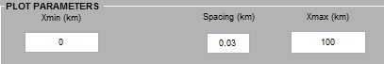

**Data Import**

The primary purpose of TAFI is to facilitate fitting of the elastic flexural model to gravity and/or vertical displacement data provided by the user. The “Open File” and “Plot Data” buttons in the “Data Import Utility” panel allow input and plotting of gravity and vertical deformation data that can be used to constrain the flexural model. The type of data file being imported is specified in the “Data Type” dropdown menu in the “Data Import Utility” panel. Free Air gravity should be used for marine flexural models and Bouguer gravity on land, as TAFI does not explicitly model the gravitational anomaly associated with surface topography. Constraints on vertical displacements are referred to in the TAFI “Data Type” menu as flexure constraints. Examples of flexure constraints include subsidence data from wells (generally in the form of horizon depth or isopach thicknesses), depth or isopach data digitized from maps, cross sections, or seismic data, and bathymetry. Once the gravity and/or flexure constraints are loaded, the “Plot Data” button at the bottom of the “Data Import Utility” is selected to plot the constraining data.

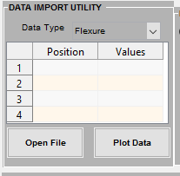

The input files containing the flexure and gravity constraints and load functions can be in either text or Excel format. The flexure and gravity constraints are read when the appropriate file type is selected from the dropdown menu in the “Data Import Utility” panel. The flexure and gravity data files should be formatted in two columns, the first providing the position (in km) of the data point relative to an origin chosen by the user, and the second column providing either the vertical deflection (in km) or gravity value (in mGal).

**Data Shift**

The imported flexure and gravity data can be shift to left, right, up or down to match the flexural and gravity models. This panel is active only when data has been imported in TAFI.

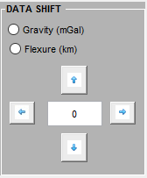

To shift the data, one of the radio button must be selected. The magnitude of shift should be selected appropriately depending on the data type. Right or left shift button, shifts the plot to the right or left and the units of shift are km for both data type. For up or down data shift, the units for gravity data is mGal and for flexure is km.

**Outputs**

The maximum deflection of the plate (wmax), amplitude of the peripheral uplift (Wb), distance from the load to the crest of the peripheral uplift (xb), and the point of zero deflection (x0) between the basin and peripheral uplift are attributes commonly used to compare flexural models to observations. These attributes are obtained in closed form for the line load models. For the point load and harmonic load models, these values are determined by searching the calculated deflection vector for the minimum, maximum and zero value (nearest to the load for the point load model, or nearest the model origin for the harmonic load model).

|  |  |  |  |  |
| --- | --- | --- | --- | --- |
| **Isostatic model** | **Cross over distance** | **Flexural Bulge Position** | **Flexural Parameter** | **Peripheral Bulge Amplitude** |
| Elastic Plate, broken _ - space, line load 2D+ |  |  |  |  |
| Elastic Plate, continuous _ - space, line load 2D+ |  |  |  |  |
| Elastic Plate, continuous _ - space, point load (3D)-,++ |  | - |  |  |
| Elastic Plate, continuous _ - space, sinusoidal load (special case)-,+ |  |  |  |  |

The outputs are given in the output panel:

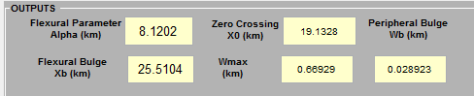

**Push Buttons**

Push buttons located below the “Model Parameters” panel control the plots shown in the “Plot panel”. The “Plot Flexure” and “Plot Gravity” buttons are needed to plot the modified flexural and gravity curves when the text boxes, rather than sliders, are used to change the model parameters. “Clear All Curves” removes the flexural and gravity curves from the plot area, leaving only the imported data plotted. “Clear All Data” removes the imported data points from the plot, leaving only the modeled curves. “Clear All Data” also erases the constraining data from the data table. “Reset All Plots” clears all curves and data from the Plot panels. After “Reset All Plots” is selected, the curves for the most recent flexural and gravity model can refreshed using the “Plot Flexure” and “Plot Gravity” buttons.

**Plot Flexure**

“Plot Flexure” button is used to plot the modified flexural curves when the text boxes, rather than sliders, are used to change the model parameters.

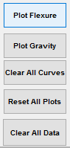

**Plot Gravity**

“Plot Gravity” button is used to plot the modified gravity curves when the text boxes, rather than sliders, are used to change the model parameters.



**Clear All Curves**

“Clear All Curves” removes the flexural and gravity curves from the plot area, leaving only the imported data plotted.



**Reset All Plots**

“Reset All Plots” clears all curves and data from the Plot panels. After “Reset All Plots” is selected, the curves for the most recent flexural and gravity model can refreshed using the “Plot Flexure” and “Plot Gravity” buttons.



**Clear All Data**

“Clear All Data” removes the imported data points from the plot, leaving only the modeled curves.



**Contextual Menu**

The "File" menu consists of:

1. Export

a. Export Flexure

Export the flexure model data in text file. The output text file has position (x - km) and flexural deflection (w - km) in 1st and 2nd columns, respectively. The default file name is

"FlexureProfile.txt".

b. Export Gravity

Export the gravity model data in text file. The output text file has position (x - km) and gravity

(g - mGal) in 1st and 2nd columns, respectively. The default file name is "GravityProfile.txt".

2. Export Parameters

a. Export Inputs

The input parameters - Flexural Rigidity, Elastic Thickness, Infill Density, Crust Density, Mantle Density, Infill-Crust interface depth, Crust-Mantle interface depth, Load Magnitude, Load Position, Load Wavelength (if used), and Plot Parameters (Xmin, spacing, Xmax) - are exported as a text file. Default name of the file is "InputParameter.txt" .

b. Export Outputs

The output parameters - Flexural Parameter, Zero Crossing, Flexural Bulge, Maximum flexural deflection, and Peripheral Bulge - are exported as a text file. Default name of the file is "OutputParameter.txt".

3. Edit Figures

a. Edit Flexure

Option to edit the properties of flexural curve, e.g. line thickness, titles, etc. using Matlab's inbuilt figure palette.

b. Edit Gravity

Option to edit the properties of gravity curve, using Matlab's inbuilt figure palette.

4. Exit

To exit TAFI gracefully.

**File**

**Change Defaults**

Change Defaults menu contains the following sub-menu:

1. Physical Constants

Physical constants used in TAFI are:

g - acceleration due to gravity (m/s^2)

E - Young's Modulus (N/m^2)

pr - Poisson's ratio (No units)

R - Earth's radius (m)

These default values are stored in DefConstant.m. Clicking on "Physical Constants" menu opens up the DefConstant.m file and allows the user to change these parameters.

2. TAFI Defaults

When TAFI is initialized, the model parameters and the ranges of the sliders are preset to default based on existing literature. These can be modified from the “Change defaults – TAFI Defaults” contextual menu in the TAFI GUI or by editing the “TAFI_Defaults.m” file.

The default values for the GUI elements used are:

|  |  |  |  |  |  |
| --- | --- | --- | --- | --- | --- |
| **SLIDERS** | | | | | |
| **GUI element** | **Minimum** | **Maximum** | | **Step Size** | **Default** |
| Flexural Rigidity (N-m) | 1015 | 1027 | | 1.84x 1019 | 1019 |
| Load (N/m or N/m2) | 1 | 1020 | | 4.38 x 10-2 | 1012 |
| Load position (km) | -1000 | 1000 | | 0.2 | 0 |
| Topographic wavelength (km) | 1 | 5000 | | 0.5 | 1 |
| **EDIT BOXES** | | | | | |
| **GUI element** | | | **DEFAULT VALUES** | | |
| Infill density (kg/m3) | | | 2280 | | |
| Crust Density (kg/m3) | | | 2800 | | |
| Mantle Density | | | 3200 | | |
| 1st Interface depth (Infill - Crust interface, m) | | | 5000 | | |
| 2nd Interface depth (Crust - Mantle depth, m) | | | 12000 | | |
| Xmin (km) | | | 0 | | |
| Spacing (km) | | | 0.03 | | |
| Xmax (km) | | | 12000 | | |
| **DROPDOWN MENU** | | | | | |
| **GUI element** | | | **DEFAULT VALUE** | | |
| Plate Geometry | | | Infinite Plate | | |
| Load Geometry | | | 2-D Line Load | | |
| Data Import Utility - Data Type | | | Flexure | | |

3. Restore All Defaults

This options restores the default files to their initial state, i.e. to the values used when TAFI was downloaded and started for the first time.

**Utilities**

Utilities menu has only one sub-menu for now - Plot Imported load. This menu plots a stem figure of the imported load function showing the distribution of the load with distance.

In future, this menu will have more features.

**About**

There are two sub-menus in the "About" menu:

1. Program Description

Opens up this help file.

2. Citation

TAFI citation in text format

**Tools**

Matlab's inbuilt tools to interact with flexural and gravity models:

1. Zoom In

2. Zoom Out

3. Data tip - read the value of a data point on flexural and gravity plots, by clicking on the plot.

4. Pan.

**Functions Callable outside TAFI**

The following functions can also be accessed from outside the TAFI, to perform flexural and gravity modeling.

|  |  |  |
| --- | --- | --- |
| **Function** | **Arguments** | **Description** |
| flexparam.m | D, γ, g, E, Te, R, loadtype,Plate | Function to calculate the flexural parameter for a given load and plate geometry. |
| Continuous2D_flex.m | α, D, x | Green's function to calculate flexural response for infinite plate and 2-D impulse load. |
| Continuous3D_flex.m | α, D, x | Green's function to calculate flexural response for infinite plate and 3-D impulse load. |
| Halfspace2D_flex.m | α, D, x | Green's function to calculate flexural response for semi-infinite plate and 2-D impulse load. |
| Harmonic2D_flex.m | x, λ, Q0, g, γ, D | Function to calculate flexural response for infinite plate and sinusoidal load. |
| ParkG.m | w, Δρ, z, Δx | Function to calculate the gravity field due to flexed elastic plate. The function can be used for plates of more than 2 interfaces. |

**Decision table for plate and load geometry combinations**

|  |  |  |
| --- | --- | --- |
| **Plate geometry** | **Load geometry** | **Geodynamic function** |
| Infinite | 2-D impulse load | Continuous2D_flex.m |
|  | 3-D impulse load | Continuous3D_flex.m |
|  | Periodic loading | Harmonic2D_flex.m |
|  | 2-D distributed load | Continuous2D_flex.m |
|  | Distributed axisymmetric load | Continous3D_flex.m |
| Semi-Infinite | 2-D impulse load | Halfspace2D_flex.m |
|  | 2-D distributed load | Halfspace2D_flex.m |